MACH4METAL

metalworking machinery
Transito 21, 6909 DA Babberich, Netherlands
Tel. + 31 (0)316 – 247123
Fax. + 31 (0)316 - 247956
info@mach4metal.com
www.mach4metal.com
Bank No : 66.52.13.883
IBAN : NL33 INGB 0665 2138 83
BIC : INGBNL2A
VAT : NL 815393635B01

DOOSAN S310MN live tool

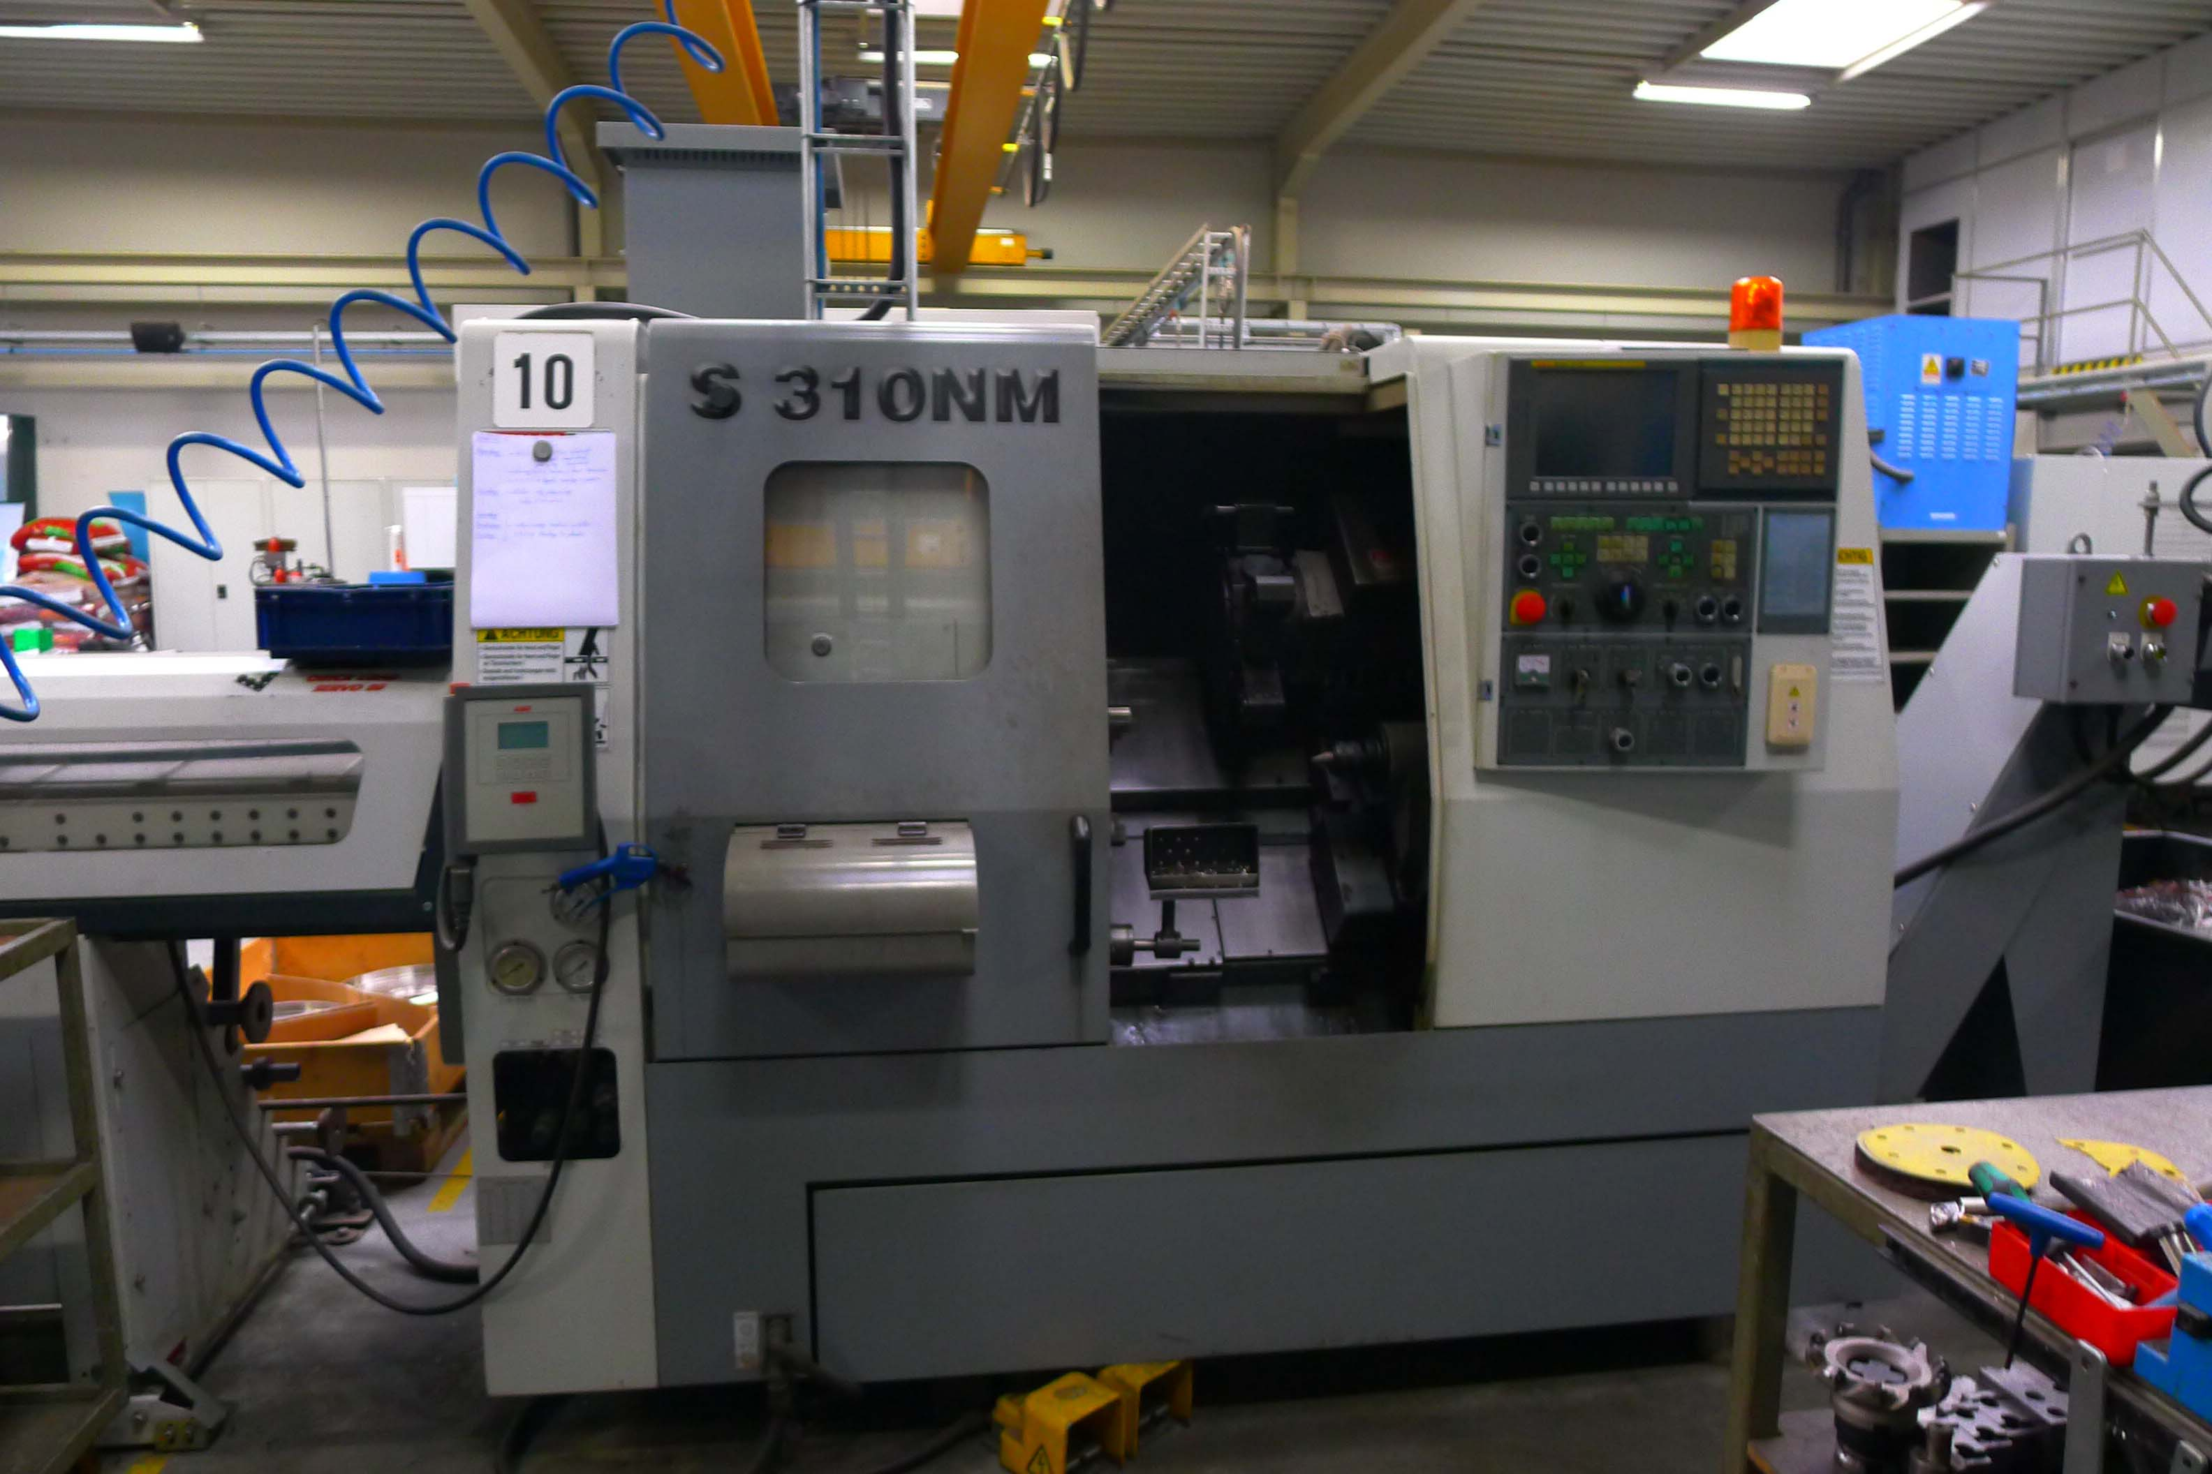
- Make : HYUNDAI
- Typ : SKT 21
- Age : 2007
- Serial :

- Swing over bed : 500
- Swing over cross : 310
- DBC turning length : 450
- Spindle bore : 51
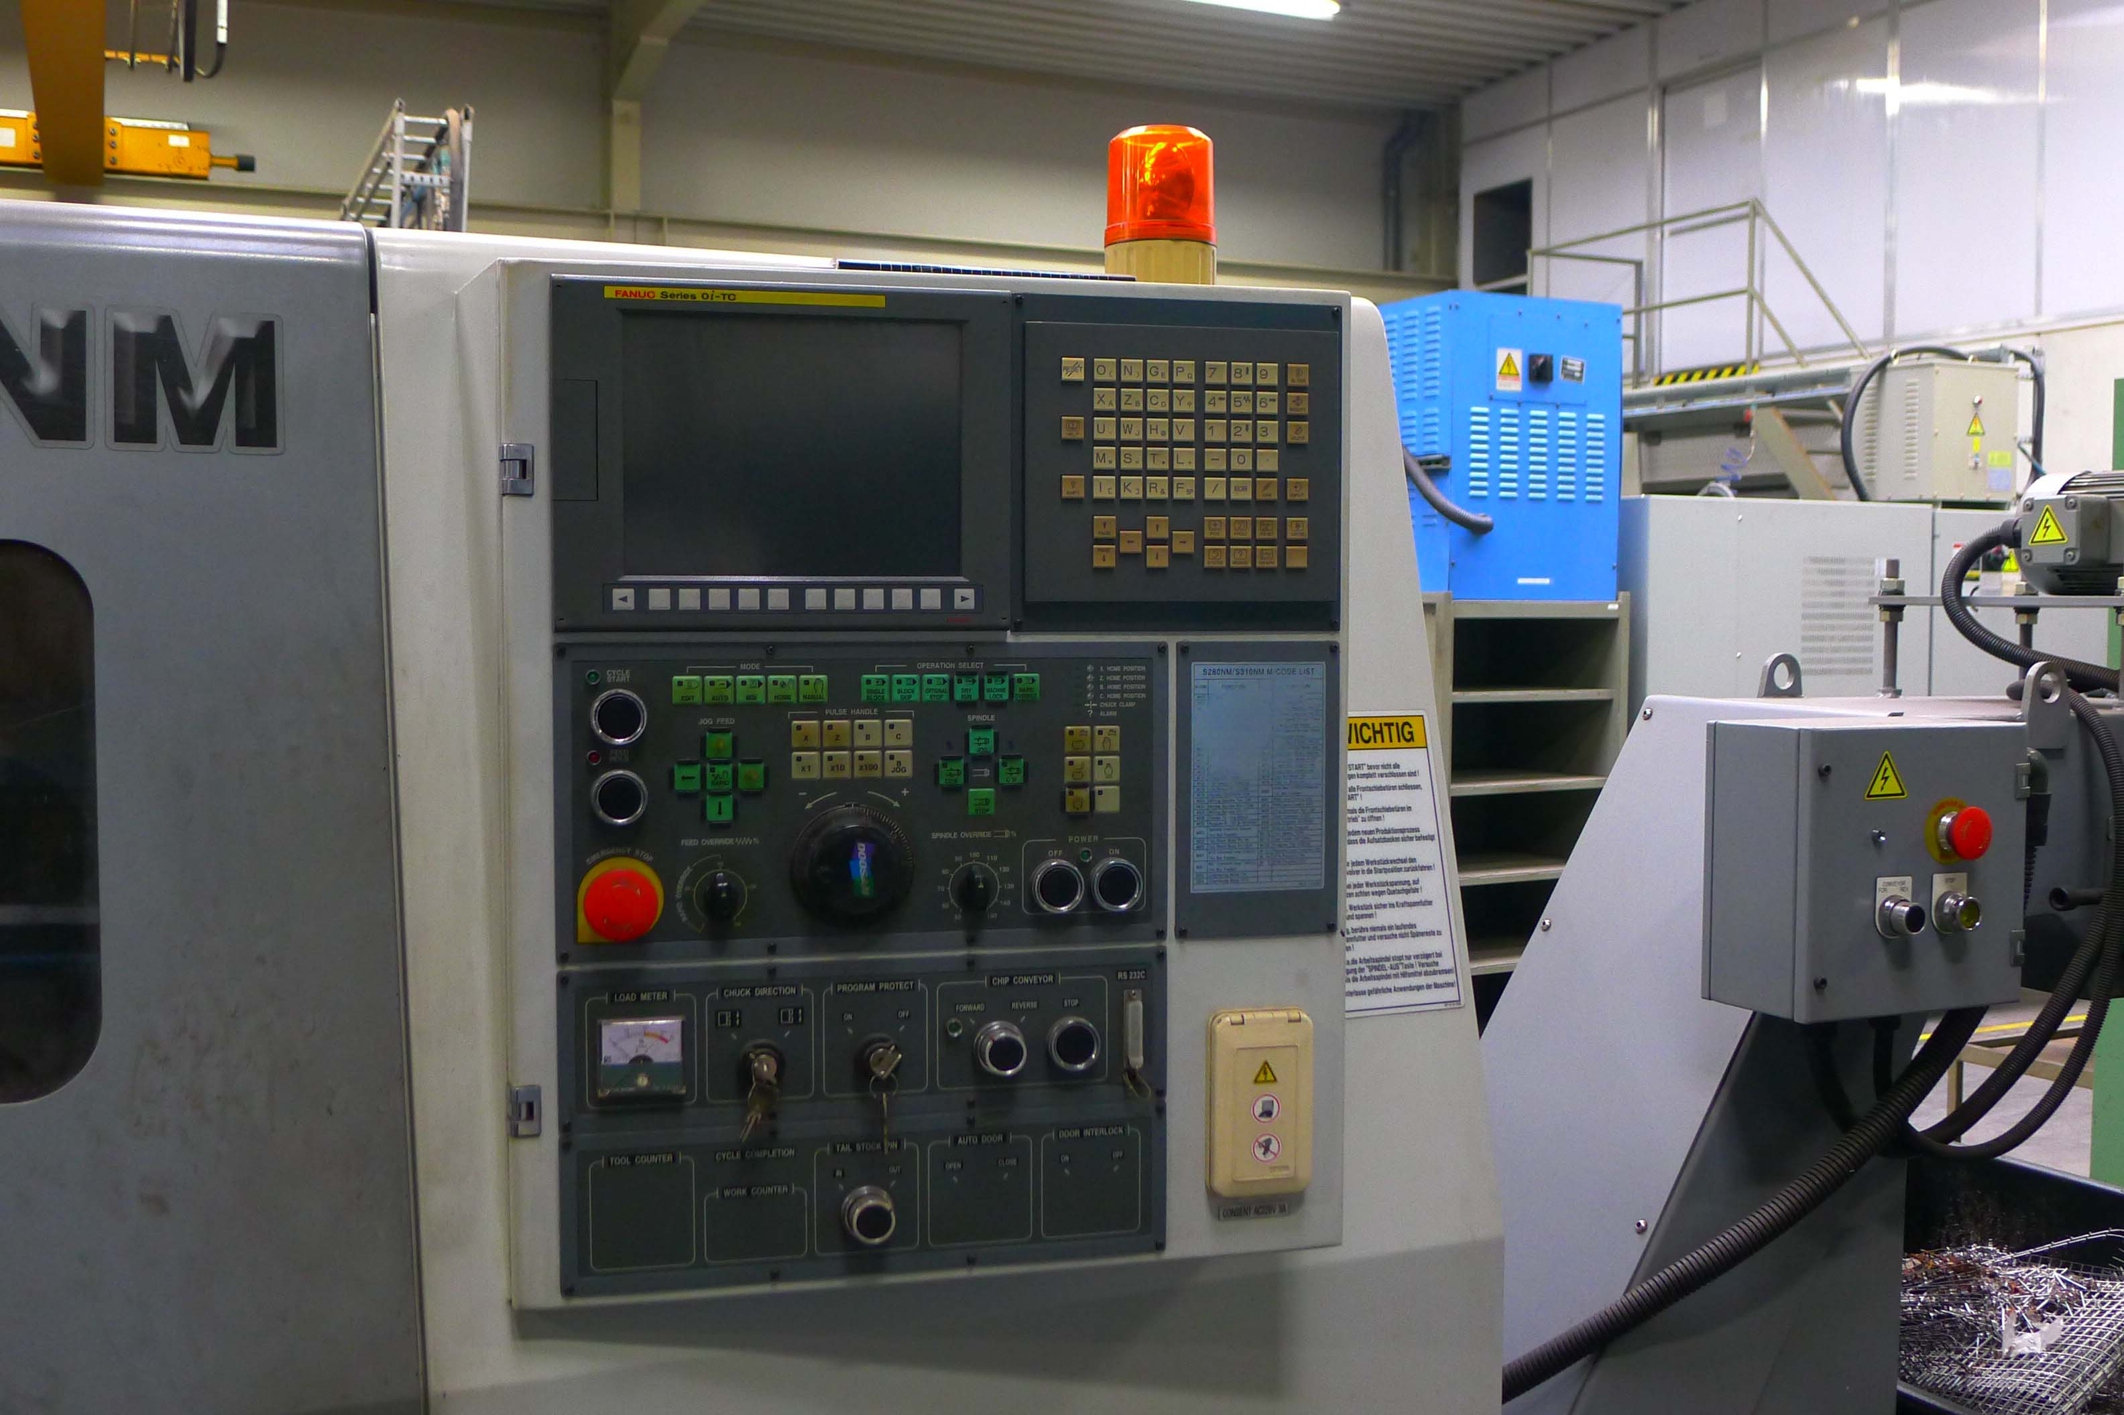
- Spindle speeds Rpm : 4.500
- Spindle main power Kw : 15

- Rapid feed X : 24.000 mm
- Rapid feed Z : 30.000 mm
- Travel X / X : 200 / 450

- Quill diameter / travel : 56 / 400
- Taper : MK 4

- ATC 12 Position incl. LIVE TOOLING
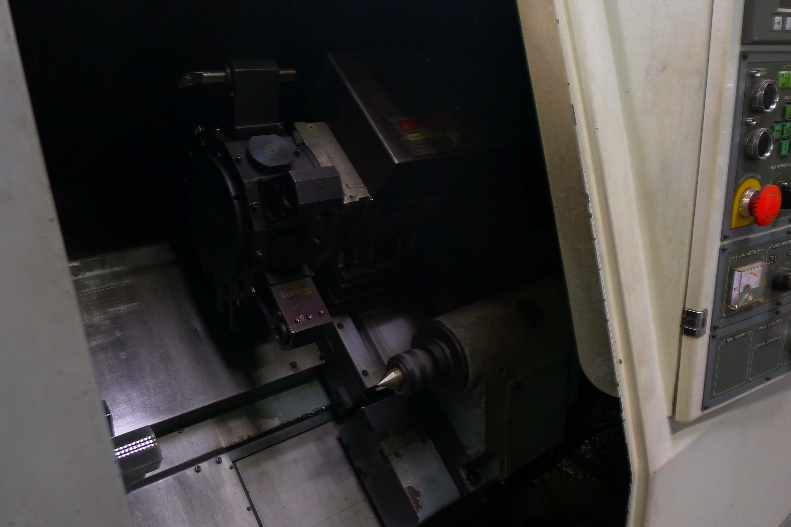
- Coolant
- Fanuc 21 iT CNC Control

- Chip conveyor
- Tool eye
- Chuck Ø with jaws
- LNS Barfeederservo speed 80

- Dimensions
- Length : 2.550
- Width : 1.850
- Height : 1.870
- Weight : 3.000

Please Note: The above information has been obtained to the best of our ability and belief from, and from the manufacturers where possible. It is given in good faith, but its accuracy can not be guaranteed. Accordingly, it will not form a representation or constitute contractual terms. We advise you to check any vital details!

